1. What is a minimum spanning tree and find out MST by using Kruskals Algorithm

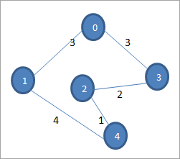

### What is an AVL tree? Construct an AVL tree having the following elements

**H, I, J, B, A, E, C, F, D, G, K, L**

1. Construct the minimum spanning tree (MST) for the given graph using Prim’s Algorithm-

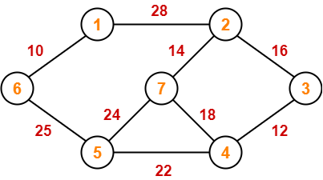

1. INSERTION SORTING
2. BFA
3. DFA
4. Overflow handling techniques
5. What is Max heap
6. Explain adjacency matrix with the help of suitable example
7. **HASHING**

**11.DIFFERENCES BETWEEN SINGLE LINKED LIST AND DOUBLE LINKED LIST**